Aim: To perform Data Exploration using Microsoft Excel.

Lab Outcome:
• Understand the concept of data exploration and its importance in business decision-making.
• Identify and classify different types of data such as nominal, ordinal, interval, and ratio.
• Create and interpret visualizations such as Pie Charts, Bar Charts, and Box Plots.

Theory:
Q1. What is Data Exploration?
Data exploration is the process of analysing and summarizing data to understand its main characteristics before applying any advanced analysis or modelling. It involves examining patterns, trends, outliers, and relationships in data using statistical and visual tools.

Q2. What are the Types of Data?
Data can be classified into four main types:
1. Nominal Data: Nominal data represents categories or labels without any specific order. Example: City names (Boston, New York, Los Angeles), Region (East, West).
2. Ordinal Data: Ordinal data represents categories with a meaningful order but without equal intervals between values. Example: Product ratings such as Poor, Average, Good, Excellent.
3. Interval Data: Interval data has ordered values with equal differences between them, but no true zero point. Example: Temperature in Celsius or Fahrenheit.

Q3. Data set used:
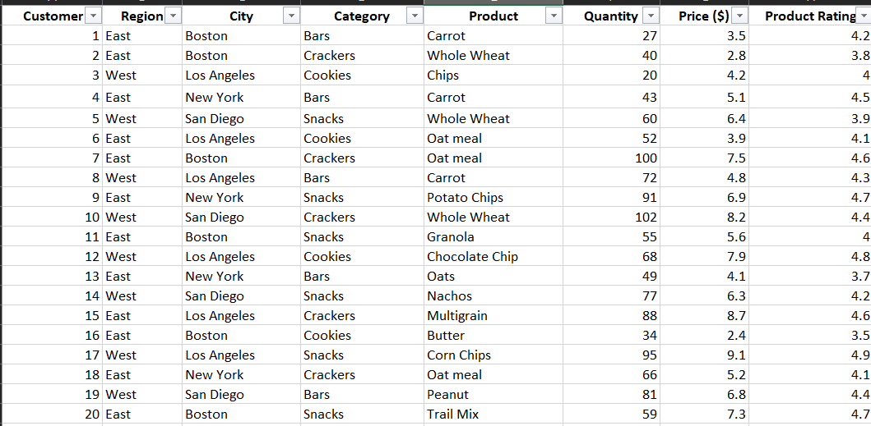
Steps to create a pie chart:
1. Enter the list of cities in column J:
• Boston
• Los Angeles
• San Diego
• New York
2. In cell K1, type Customer Count.
3. In cell K2, enter the formula: =COUNTIF(C2:C21, J2)
4. Drag the formula down to get the count for all cities.
5. Select the range J1:K5.
6. Go to Insert → Pie Chart → 2-D Pie.
7. Give the chart title as: Customer Distribution by City The pie chart shows how customers are distributed among different cities. Boston and Los Angeles have the highest number of customers, while San Diego and New York have fewer customers.

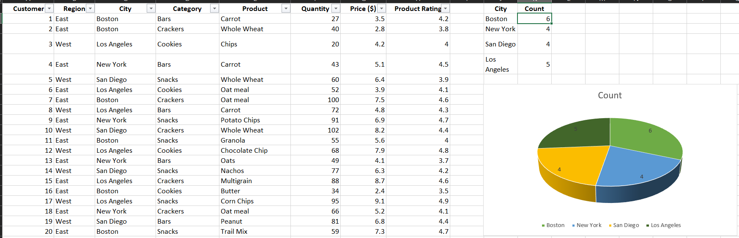

Steps to create a bar chart:
1. Use the same city list in column J.
2. In cell K1, type Average Rating.
3. In cell K2, enter this formula: =AVERAGEIF(C2:C21, J2, H2:H21)
4. Drag the formula down to calculate average ratings for all cities.
5. Select the range J1:K5.
6. Go to Insert → Column Chart.
7. Add titles:
o Chart Title: Average Product Rating by City
o X-Axis: City
o Y-Axis: Average Rating
The graph compares the average customer ratings of products across different cities. Los Angeles has the highest average rating, indicating higher customer satisfaction.

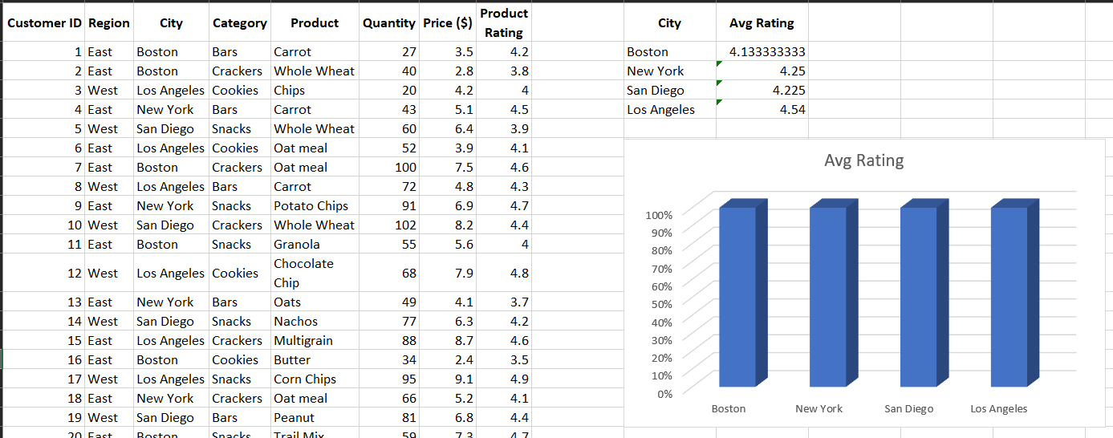

Steps for box and whisker:
East Column (J2) formula to enter to get the quantity of Bars sold in the east region:
=FILTER(F:F,(B:B="East")*(D:D="Bars"))

West Column (K2) formula to enter to get the quantity of Bars sold in the west region:
=FILTER(F:F,(B:B="West")*(D:D="Bars"))

1. Create headers East and West.
2. Enter the above formulas.
3. Select the generated data.
4. Go to Insert → Statistical → Box & Whisker.
The box plot shows that the West region has higher median and spread of quantity ordered for Bars compared to East.

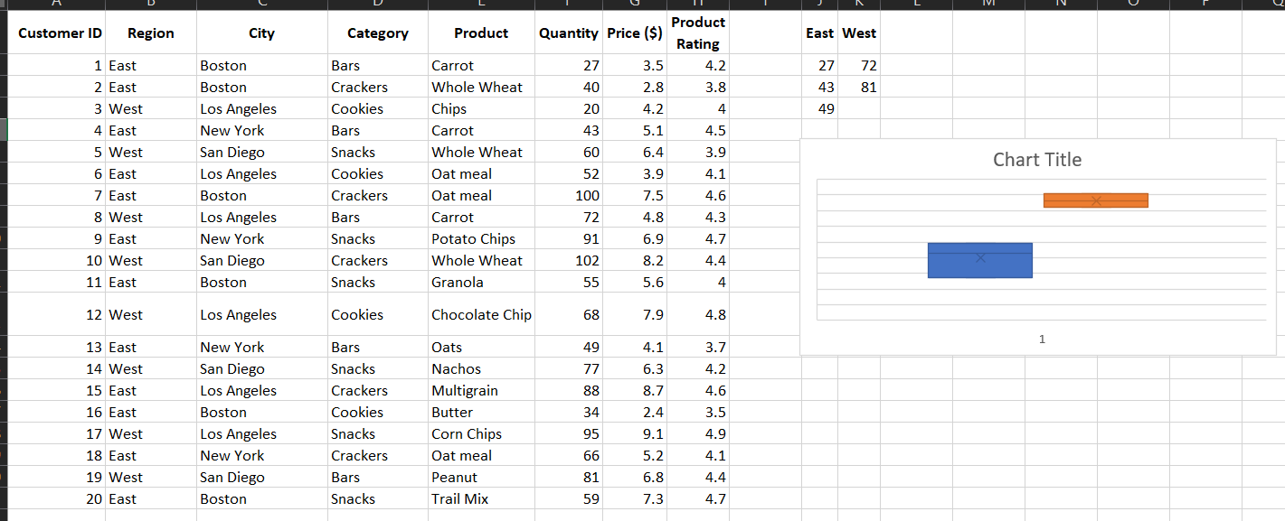

Conclusion
This practical demonstrated how Excel can be used for effective data exploration and visualization. By using charts such as Pie Charts, Bar Graphs, and Box Plots, meaningful insights about customer distribution, product ratings, and regional demand were obtained. These visual tools help in better understanding of business data and support informed decision-making.

